Screening Process (Participants)
All registrants, players, instructors will undergo a COVID-19 pre-screening by filling out an online health questionnaire based on the questionnaire provided by the OHF:
The Participant Questionnaire will be completed online where it can be and found on the GMHA webpage and under the Heading “COVID-19 Screening Forms”. Each team will have their own “specific” set of forms.
The questionnaire will be required to be completed and submitted no earlier than 12 hours prior to each session. If it is not completed the Participant will not be allowed to enter the arena!

For Mobile Users:
1. Navigate to the Glanbrookminorhockey.com website and Select Menu as Highlighted below.
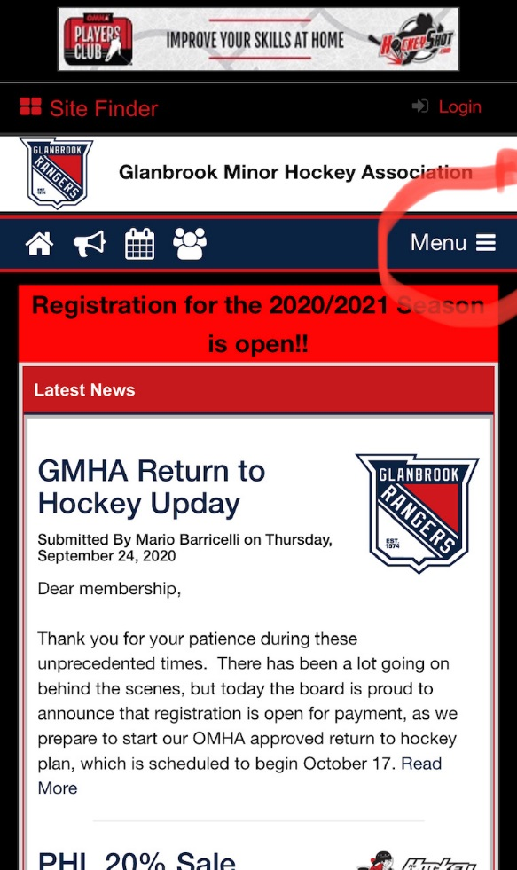

2. Select your Team under the heading of “COVID-19 Screening Forms”
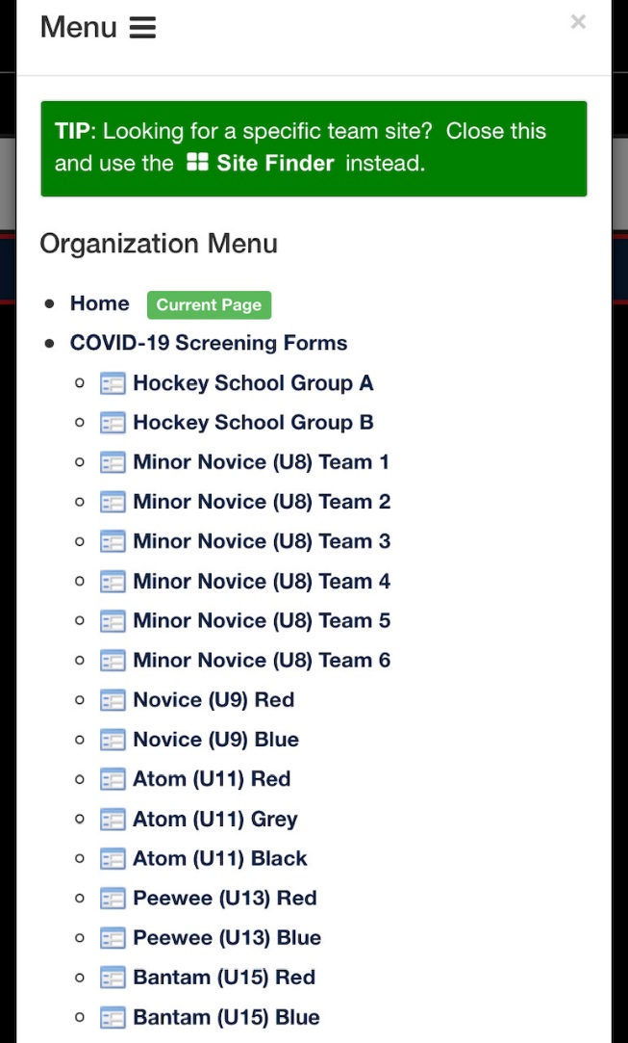

For Desktop Users:

1. Navigate to the Glanbrookminorhockey.com website and Select the heading “COVID-19 Screening Forms” as seen below.

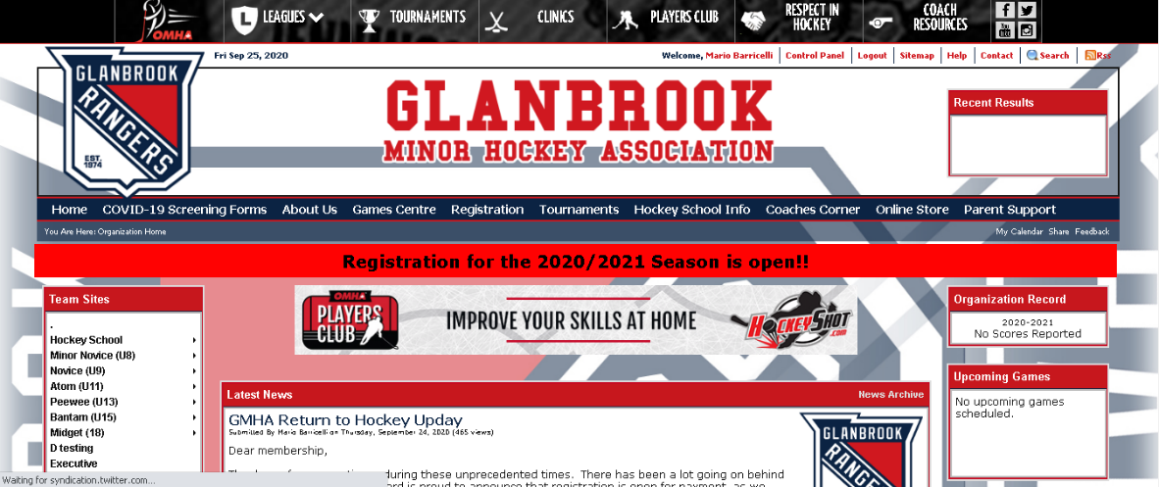

2. Select your Team from the list and the form will load.
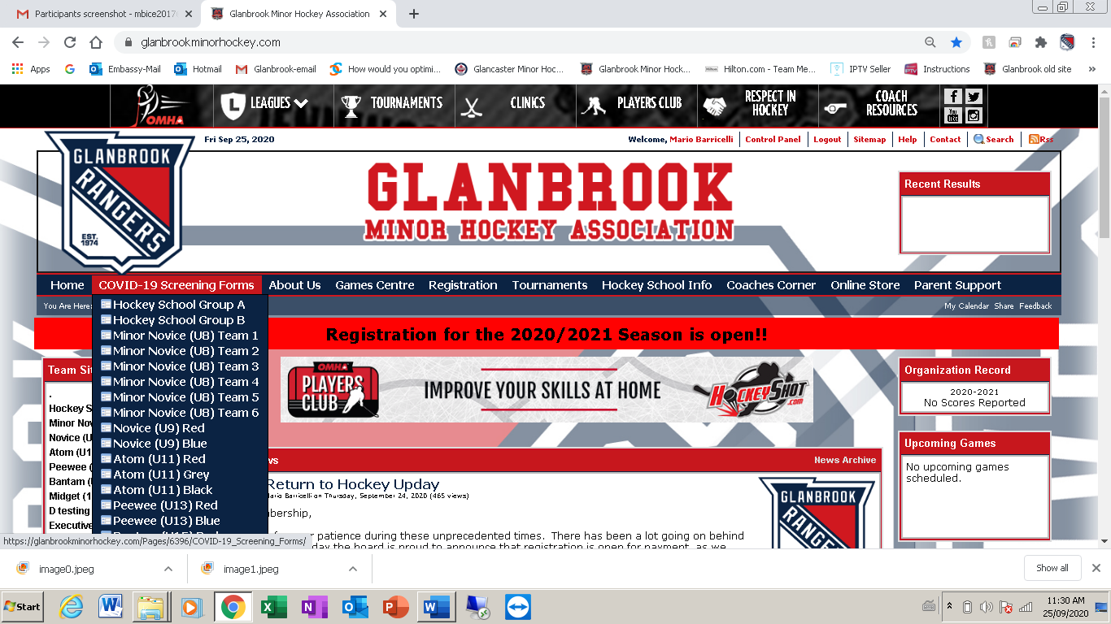

3. Read and complete the form very carefully, once complete click “Submit”. This will automatically email the trainer/or Covid volunteer of your team.

4. The questionnaire will be required to be completed and submitted no earlier than 12 hours prior to each session. If it is not completed the Participant will not be allowed to enter the arena!

